Tobacco Related Questionnaire

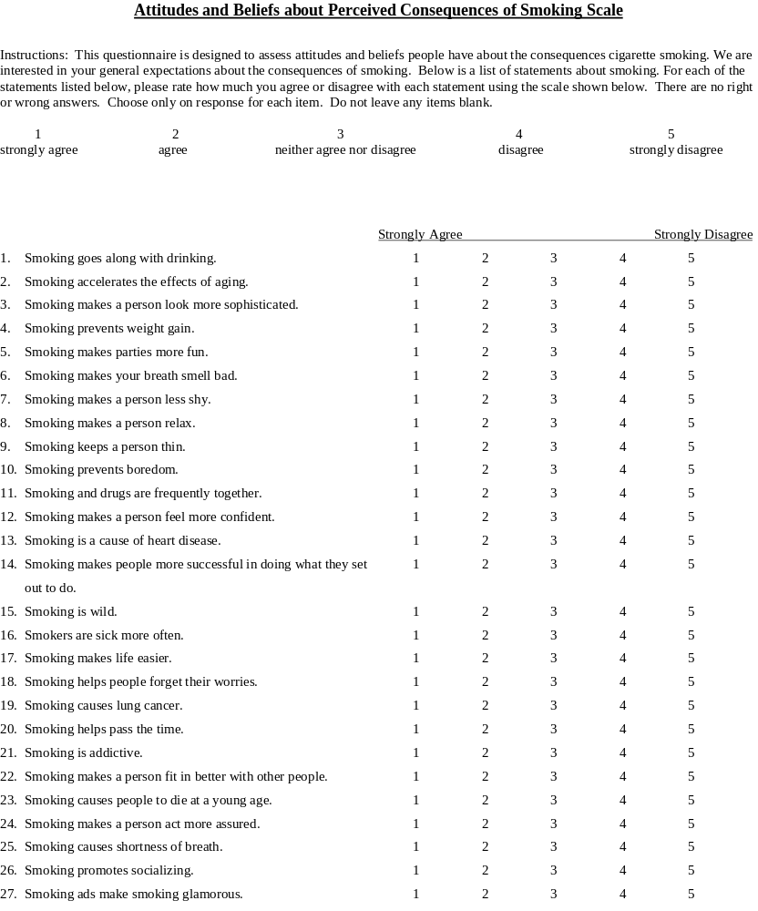

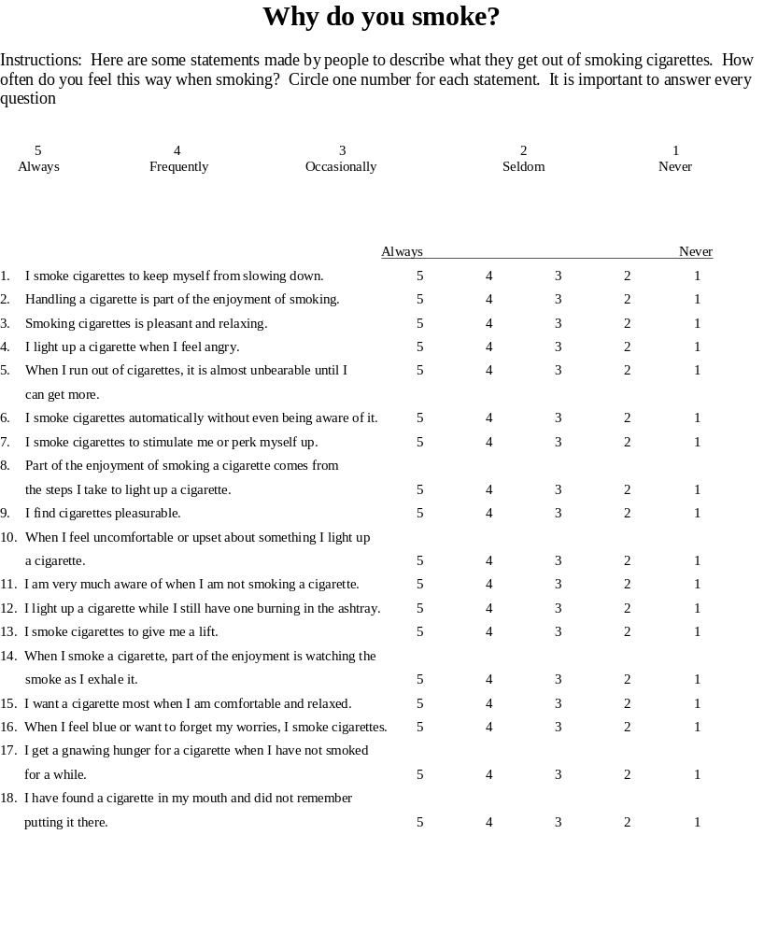
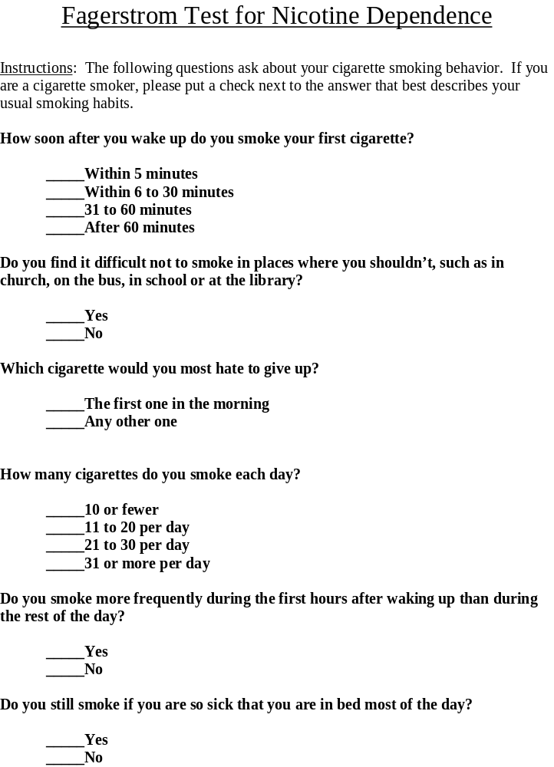

Withdrawal Symptoms Checklist (WSC)**

DIRECTIONS: Please rate (circle) the degree to which each of the following descriptive phrases applies to you AT THIS MOMENT.

 | Not Present | Mild | Moderate | Severe
1. Craving for tobacco | 0 | 1 | 2 | 3
2. Feeling irritable | 0 | 1 | 2 | 3
3. Feeling anxious | 0 | 1 | 2 | 3
4. Having difficulty concentrating | 0 | 1 | 2 | 3
5. Feeling restless | 0 | 1 | 2 | 3
6. Having a slower heartbeat | 0 | 1 | 2 | 3
7. Feeling hungry | 0 | 1 | 2 | 3
8. Feeling down/depressed | 0 | 1 | 2 | 3
9. Feeling angry | 0 | 1 | 2 | 3
10.Feeling frustrated | 0 | 1 | 2 | 3
11.Had difficulty sleeping last night | 0 | 1 | 2 | 3

**Adapted from Hughes, J.R. & Hatsukami, D.K. (1986). Signs and symptoms of tobacco withdrawal. Archives of General Psychiatry, 43, 289-294: and the American Psychiatric Association. (1994). Diagnostic and Statistical Manual of Mental Disorders. (4th ed.). Washington, DC: Author.
These individual items are not copyrighted material.

